Updating 2D List Cells

Look at this code:
clubs = [["Art", 12], ["Chess", 18], ["Code", 15]]
row = int(input("Club row 0 to 2: "))
new_members = int(input("New member count: "))
clubs[row][1] = new_members
print("Updated record:", clubs[row])
print("All records:", clubs)

What do you think this code will display?
Click or tap here to enter text.

Run the code. Compare the result with your prediction:
Click or tap here to enter text.

Let’s investigate! Answer the questions below:
- Which of the two indexes selects the row, and which selects the field to update?
Click or tap here to enter text.

- Why does clubs[row][1] = new_members leave the club name unchanged?
Click or tap here to enter text.

- What happens if new_members is not converted to int() before it is stored?
Click or tap here to enter text.

- How could choosing the wrong column silently replace a name with a number?
Click or tap here to enter text.

Updating 2D List Cells

Look at this code:
clubs = [["Art", 12], ["Chess", 18], ["Code", 15]]
row = int(input("Club row 0 to 2: "))
new_members = int(input("New member count: "))
clubs[row][1] = new_members
print("Updated record:", clubs[row])
print("All records:", clubs)

Use the code above to help you. After completing each challenge below, run your program to test that it works correctly. Save each completed challenge program in a new file.

Programming Challenges

Challenge 1
Change the second input so the user adds members instead of replacing the total. Test row 2 and add 2; "Code" should have 17 members and the other records should stay unchanged.
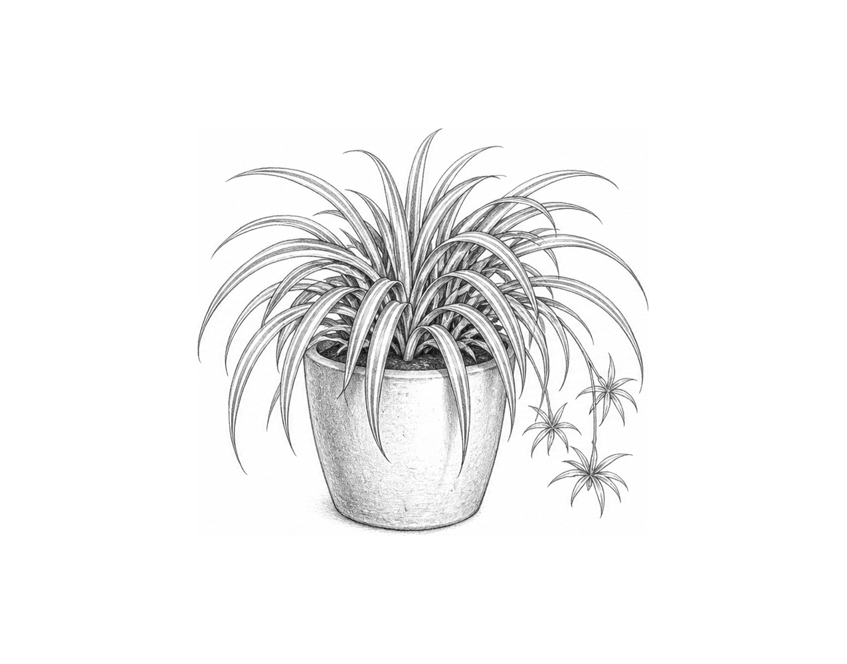

Challenge 2
Ask for a row from 0 to 2 and store it in [row]. Display "Before:" followed by [clubs][row]. Ask for a new club name and member count and store them in [new_name] and [new_members]. Update both cells in the selected row, then display "After:" followed by the updated row. Test row 1, "Robotics" and 22; display "Before: ['Chess', 18]" and "After: ['Robotics', 22]".

Challenge 3
Store the rows ['Pens', 10], ['Books', 6] and ['Tape', 4] in [stock]. Ask for a row from 0 to 2 and store it in [row]. Ask for a delivery amount and store it in [delivery], then add [delivery] to the quantity at [stock][row][1]. Display the updated row followed by every item name and quantity. Test row 2 and delivery 3; the updated row must be ['Tape', 7].

Updating 2D List Cells

Fix the code!

This code has errors! Look closely at the code to find the problems:

clubs = [["Art", 12], ["Chess", 18]]
row = 1
new_members = input("New member count: ")
clubs[row, 1] == new_members
print(clubs)

Rewrite the whole program in the box below with fixes to the errors.
Click or tap here to enter text.

After you are confident that you fixed all the errors, copy the code from the box and run it.

Did it work correctly on your first try? Did you find all the errors?
Click or tap here to enter text.

